

**A MINI PROJECT REPORT**

#### ON

# ****CYBERBULLYING TWEET PREDICTION****

## *Submitted in partial fulfillment for the award of the degree of Bachelor of Engineering*

#### *In*

**COMPUTER ENGINEERING**

***Submitted by***

**K. KUMAR BRAHMA VENKATA SAI 20191COM0090 - 7COM-02**

**K. MAHESWAR REDDY 20191COM0091 - 7COM-02**

**K. HEMANTH KUMAR 20191COM0093 - 7COM-02**

**K. SUDHARSHAN REDDY 20191COM0095- 7COM-02**

**K. ROHITH SAI 20191COM0096-7COM-02**

**K. VARUN KUMAR REDDY 20191COM0097-7COM-02**

***Reviewed by***

#### Dr.PAMELA VINITHA ERIC

#### Professor,CSE



Certificate

# This is to certify that the mini project work titled

[CYBERBULLYING TWEET PREDICTION]

##### *Submitted in partial fulfillment for the award of the degree of Bachelor of Engineering*

**K. KUMAR BRAHMA VENKATA SAI 20191COM0090 - 7COM-02**

**K. MAHESWAR REDDY 20191COM0091 -7COM-02**

**K. HEMANTH KUMAR 20191COM0093 -7COM-02**

**K. SUDHARSHAN REDDY 20191COM0095-7COM-02**

**K. ROHITH SAI 20191COM0096-7COM-02**

**K. VARUN KUMAR REDDY 20191COM0097-7COM-02**

**During the academic year**

***2022-2023***

|  |  |  |
| --- | --- | --- |
|  |  |  |
| **Signature of Reviewer** |  | **Signature of IC** |

|  |  |  |
| --- | --- | --- |
| **TABLE OF CONTENTS** | | |
|  | | |
| **CHAPTER NO** | **TITLE** | **PAGE NO** |
|  | **Acknowledgement** | v |
|  | **List of Figures** | vi |
|  | **Abstract** | vii |
| 1 | **Introduction** | viii |
| 2 | **Analysis and Design** | ix |
| 2.1 | Objectives of the Project |  |
| 2.2 | Requirement Specification |  |
| 3 | **Methodology** | x |
| 3.1 | Conceptual Diagram | xiii |
| 3.2 | Implementation |  |
| 3.2.1 | Data Importing and EDA |  |
| 3.2.2 | Text Processing |  |
| 3.3 | Initial Model |  |
| 3.4 | Classifier Model |  |
| 4 | **Sample Output** | xx |
| 5  6 | **Conclusion**  **Bibliography** | xxi  xxii |
|  |  |  |

**LIST OF FIGURES**

**Figure No Figure Name Page No**

Figure 1.2 Conceptual Diagram xiii

# ACKNOWLEDGEMENT

The satisfaction and euphoria that accompany the successful completion of any task would be, but impossible without the mention of the people who made it possible, whose constant guidance and encouragement crowned my efforts with success.

### We thank the management, Dr. Nissar Ahmed, Chancellor Presidency University, for providing necessary infrastructure and creating a good environment.

We also record here the constant encouragement and facilities extended to me by

**Dr. Mohammed Sameeruddin Khan**, Dean, SOCSE & IS, Presidency University, **Dr. C Kalaiarasan, Assoc.** Dean, SOCSE & IS, Presidency University. I extend my sincere gratitude to them.

We express our gratitude to **Dr. Pamela Vinitha Eric**, Professor, Department of Computer Science and Engineering, Presidency University, our project reviewer for constantly monitoring the development of the project and setting up precise deadlines. Her valuable suggestions were the motivating factors in completing the work.

Finally, a note of thanks to all the teaching and non-teaching staff of School of Computer Science and Engineering and Information Science for their cooperation extended to me and my friends, who helped us directly or indirectly in the course of the project work.

**K. KUMAR BRAHMA VENKATA SAI 20191COM0090 - 7COM-02**

**K. MAHESWAR REDDY 20191COM0091 -7COM-02**

**K. HEMANTH KUMAR 20191COM0093 -7COM-02**

**K. SUDHARSHAN REDDY 20191COM0095-7COM-02**

**K. ROHITH SAI 20191COM0096-7COM-02**

**K. VARUN KUMAR REDDY 20191COM0097-7COM-02**

**ABSTRACT**

Social networking platforms have given us incalculable opportunities than ever before, and its benefits are undeniable. Despite benefits, people may be humiliated, insulted, bullied, and harassed by anonymous users, strangers, or peers. Cyberbullying refers to the use of technology to humiliate and slander other people.

It takes form of hate messages sent through social media and emails. With the exponential increase of social media users, cyberbullying has been emerged as a form of bullying through electronic messages.

We have tried to propose a possible solution for the above problem, our project aims to predict cyberbullying in tweets using ML Classification algorithms like Naïve Bayes, KNN, Decision Tree, Random Forest, Support Vector etc. and also we will apply the NLTK (Natural language toolkit) which consist of bigram, trigram, n-gram and unigram on Naïve Bayes to check its accuracy.

Finally, we will compare the results of proposed and baseline features with other machine learning algorithms. Findings of the comparison indicate the significance of the proposed features in cyberbullying detection

**INTRODUCTION**

Nowadays technology has become a very important part of our lives and most people can't live without it. The Internet provides a platform to share their ideas. Many people are spending a large amount of time on social media. Communicating with people is no exception, as technology has changed the way people interact with a broader manner and has given a new dimension to communication. Many people are illegally using these communities.

Bullies use various services like Twitter, Facebook and Email to bully people. Studies show that about 37% of children in India are involved in cyber bullying and nearly 14% of bullying occurs regularly.

Cyber bullying is an act of threatening, harassing or bullying someone through modern ways of communicating with each other and with anybody/everybody in the world via social media apps/sites. Cyber bullying is not just limited to creating a fake identity and publishing/posting some embarrassing photo or video, unpleasant rumors about someone but also giving them threats. The impacts of cyber bullying on social media are horrifying, sometimes leading to the death of some unfortunate victims.

Thus, a complete solution is required for this problem. Cyber bullying needs to stop. The problem can be tackled by detecting and preventing it by using a machine learning approach, this needs to be done using a different perspective.

.

**ANALYSIS**

**Objectives of the Project:**

* The main purpose of our paper is to develop an ML model so it can detect and prevent social media bullying, so nobody will have to suffer from it.
* The proposed technique is implemented on the social media bullying dataset which was collected from various sources like Kaggle, GitHub, etc. The performance of SVM is compared to TFIDF.

**Requirements**

**Hardware Requirements:**

* Processor: Intel Core i5-1235U(up to 4.4 GHz)
* RAM: 8GB
* Hard disk: 512 GB

**Software requirements:**

* CPU: Intel Core i5-1234U
* RAM: 4 GB/8 GB
* Size: 2 GB
* GPU: NVIDIA GeForceGTX 970 / AMD Radeon RX 480
* Twitter Dataset
* Google collab with required Libraries.

**Implementation**

This project will be developed using python, ML. To implement the model the steps to be followed are:

🡪Dataset preparation and pre-processing

🡪Featurization

🡪 Data splitting

🡪Modelling Evaluation

🡪 Hyper parameter Tuning

🡪 Model Testing

**Data preparation :**

1**.**We will be using the dataset cyberbullying_tweets.csv from kaggle

2.Using pandas ,we will be importing the dataset into the data frame

3.Exploratory Data Analysis will be done on the imported data in the data frame printing.

🡪 a. Value counts of each category

🡪b. Length of the dataset

🡪c. Info of the data frame

🡪d. Checking null values

🡪e. Storing data in the lists

🡪f. Encoding the labels

4.Next step is text processing ,

* a.We will be converting tweet texts to lower case
* b.Stopwords: Stop words are those high frequency words that are deemed unlikely to be useful for searching.They have less semantic weights.All such words in a list are called stopwords.

Example :

"in","of","for","at" etc.

Stopwords are excluded from the data

* c. cleaning and removing punctuations,repeating characters,URLs,numeric data,
* d.Tokenization of Tweet text after the updations
* e. Stemming :Stemming, the simplified form of morphological analysis, is the heuristic process of extracting the base form of words.

Example:

laughs,laughed,laughing comes from root word "laugh"

* f. Lemmetization : Lemmatization is the process of grouping together the different inflected forms of a word so they can be analyzed as a single item. Lemmatization is similar to stemming but it brings context to the words

Example:

"better" : "good"

* 5. Exploratory data analysis on the updated data set
* 6. Plotting wordcloud excluding other_cyberbullying and not_cyberbullying
* 7. Intial modelling: it can be said as a proposed model for the project
* 8. Classifier Model :

Here we will be designing a classifier model which includes,

a.Importing the Dataset “cyberbullying_tweets.csv”

b.Encoding the classification values.

c.Text Preprocessing –

1.Converting the tweet texts to lower case.

2.Removing Stop Words from the tweet text.

3.Cleaning and removing the punctuations,URLs,repeating characters and numbers.

4.Tokenization of tweet data

5.Stemming

6.Lemmatization

7.Defining Preprocess Function

8. Model Training

8.1 Splitting data into train and test

8.2 Transforming the data using TD-IDF Vectorizer

8.3 Dumping the Vectoriser

8.4 Custom input prediction.

**CONCEPTUAL DIAGRAM**

KAGGLE

DATASET

PREPROCESSING

COUNT VECTORIZE

YES

NO

RELIGION

ETHNICITY

GENDER

AGE

OTHER

NOT BULLYING

CYBERBULLYING

SUPPORT VECTOR MODEL

APPLY MODEL

END

PREDICTION

1.IMPORTING LIBRARIES

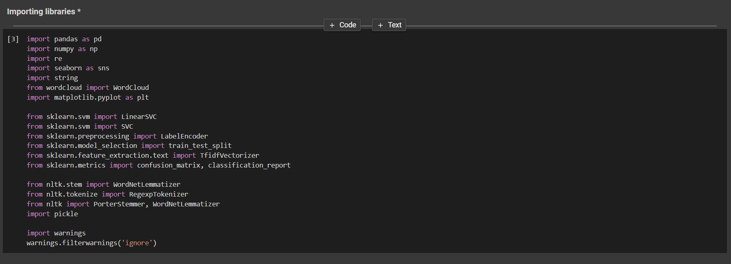

2.DATA COLLECTION AND DESCRIPTION

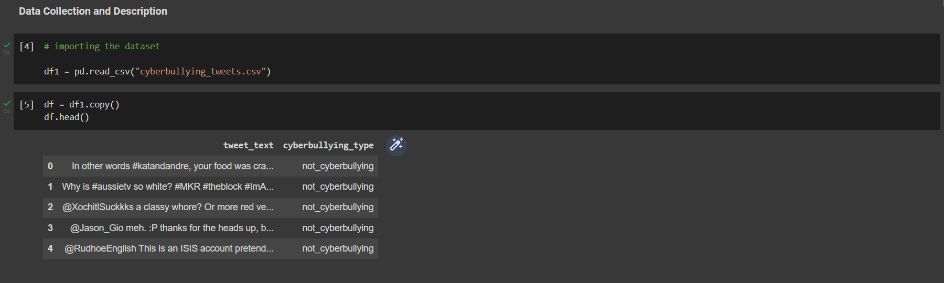

3.EXPLORATORY DATA ANALYSIS

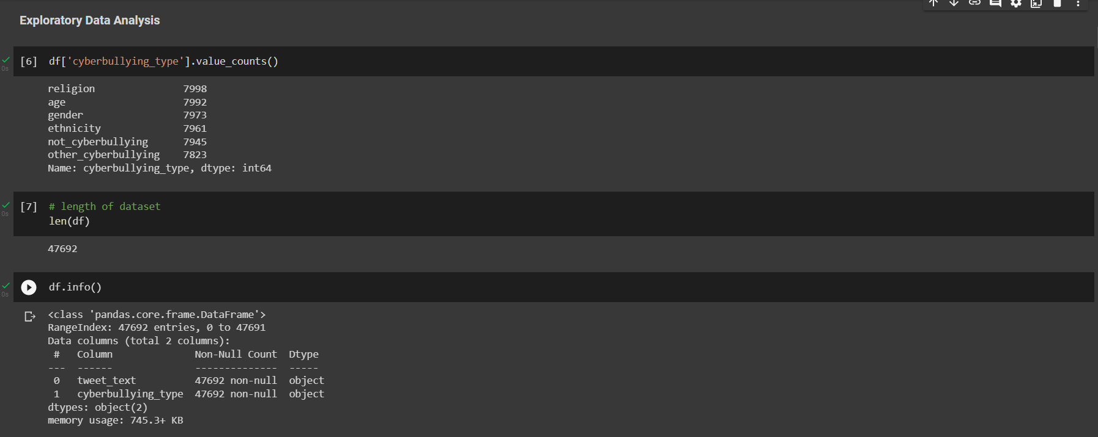

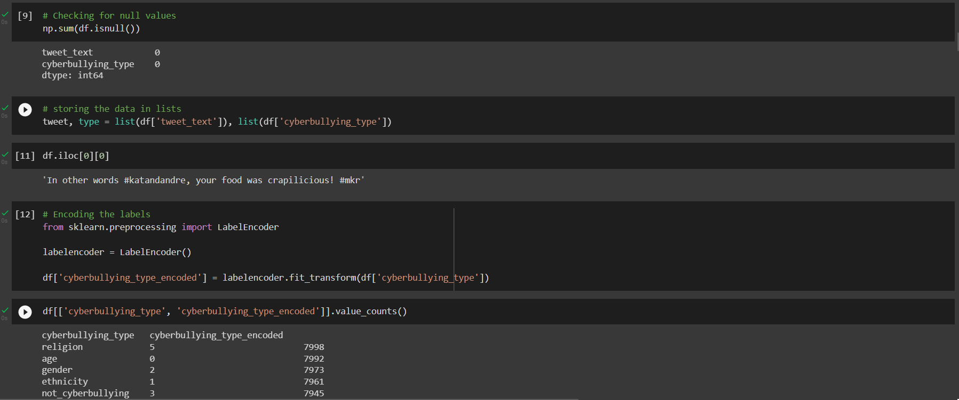

4.TEXT PROCESSING

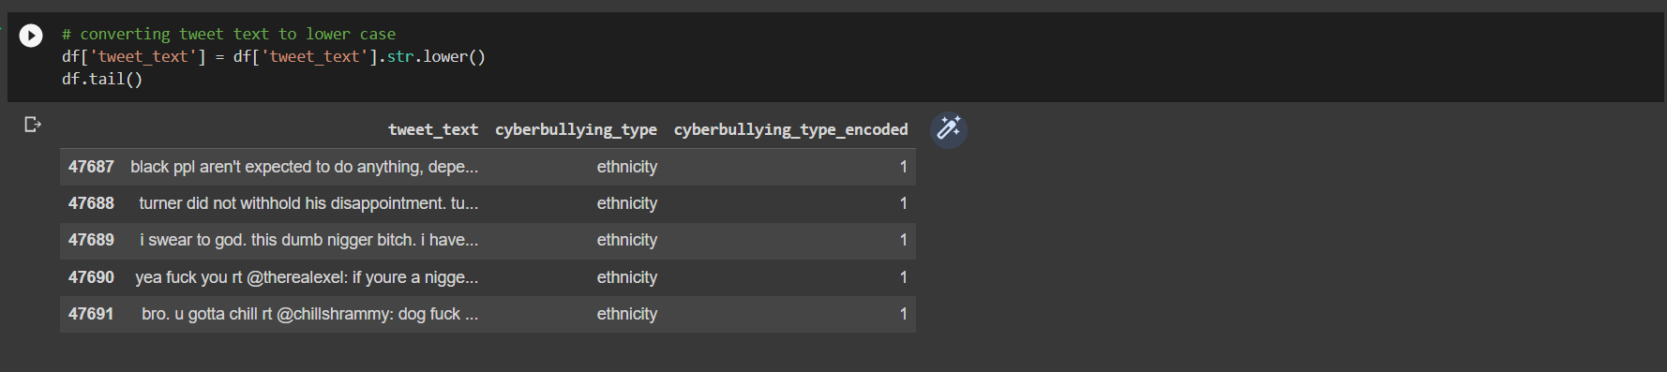

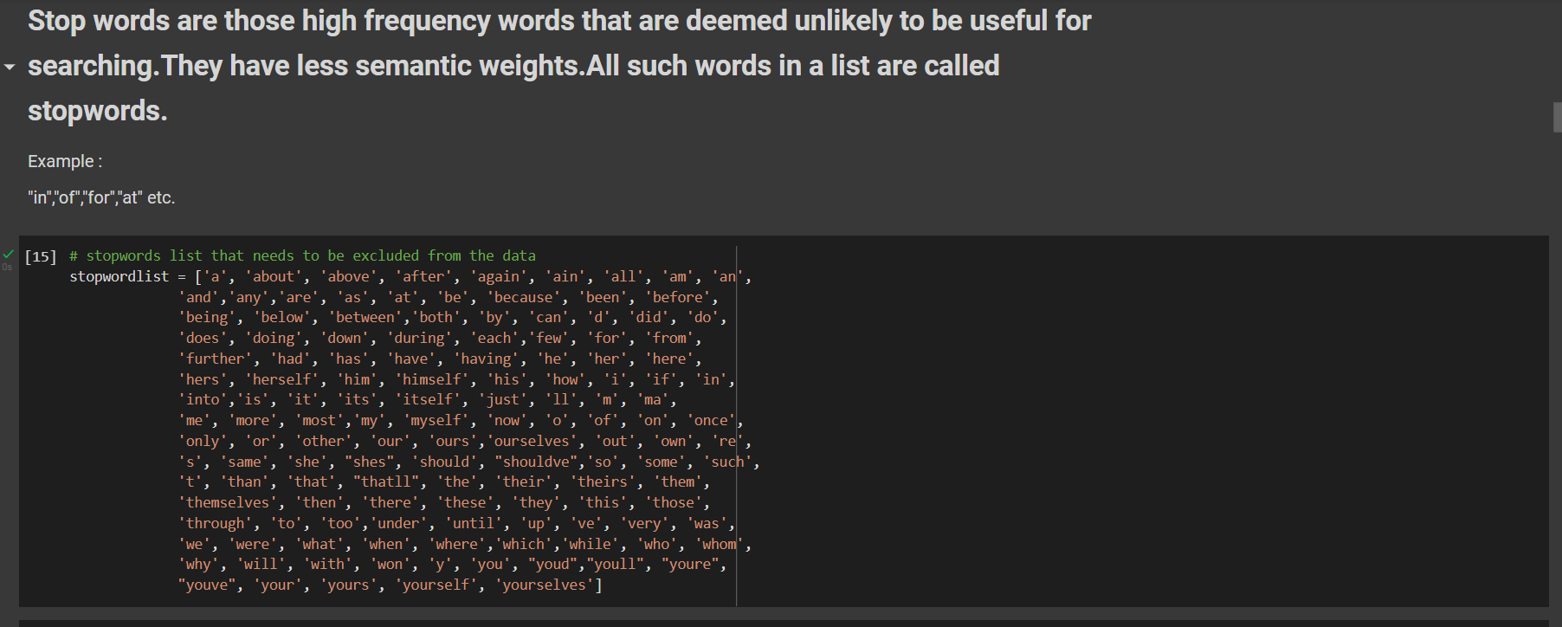

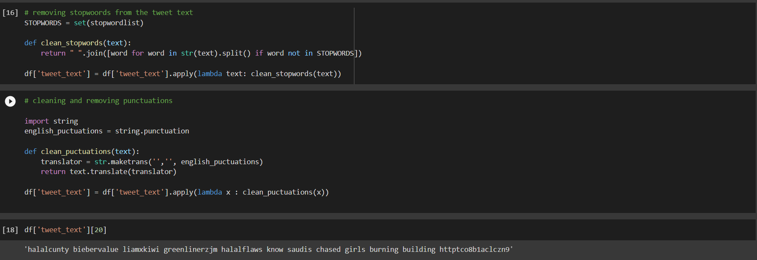

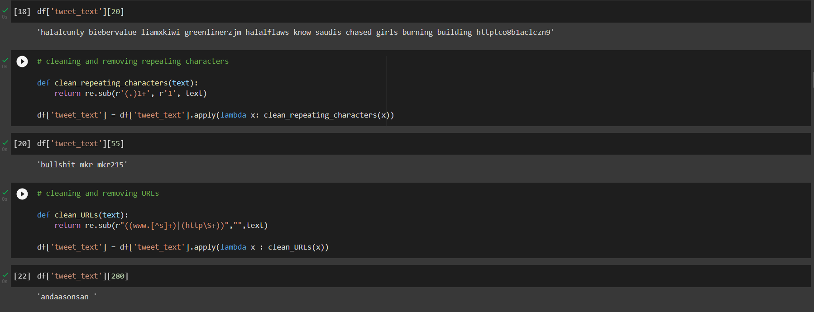

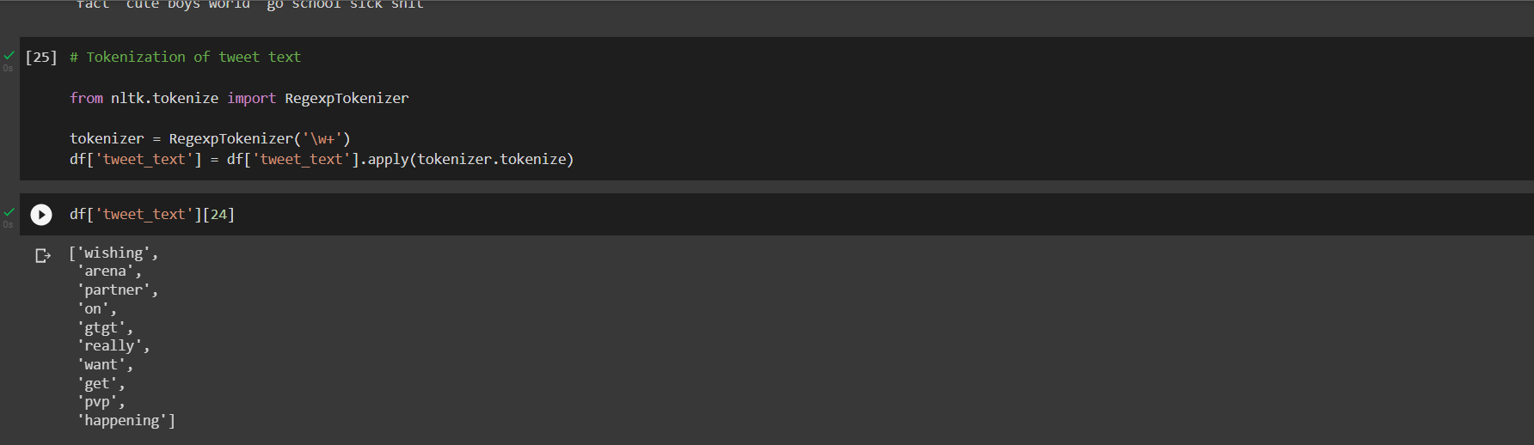

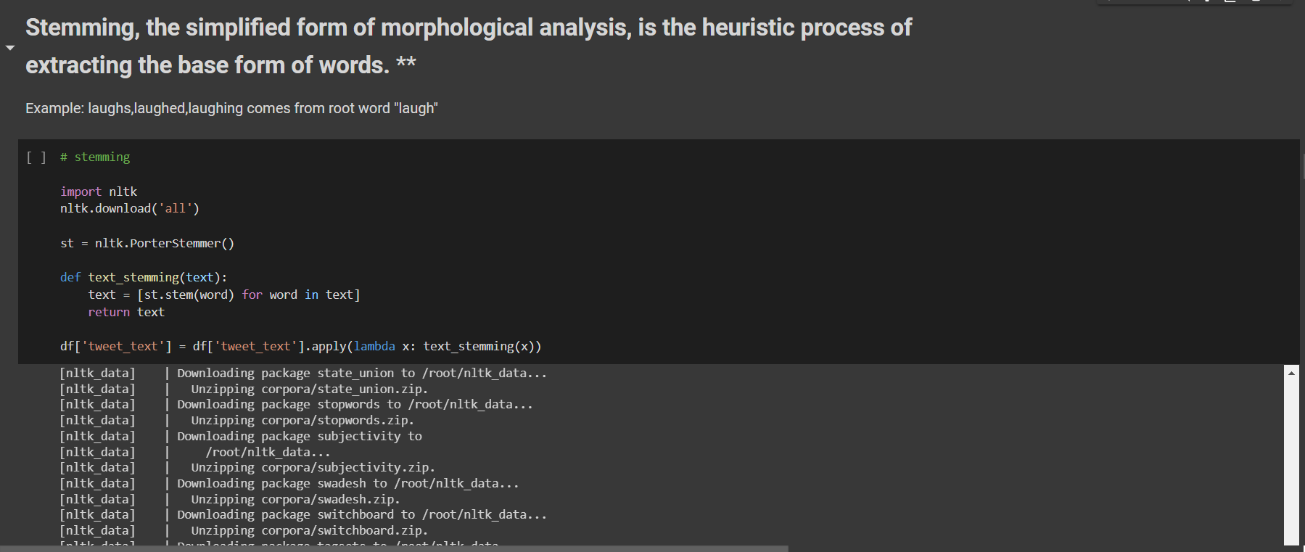

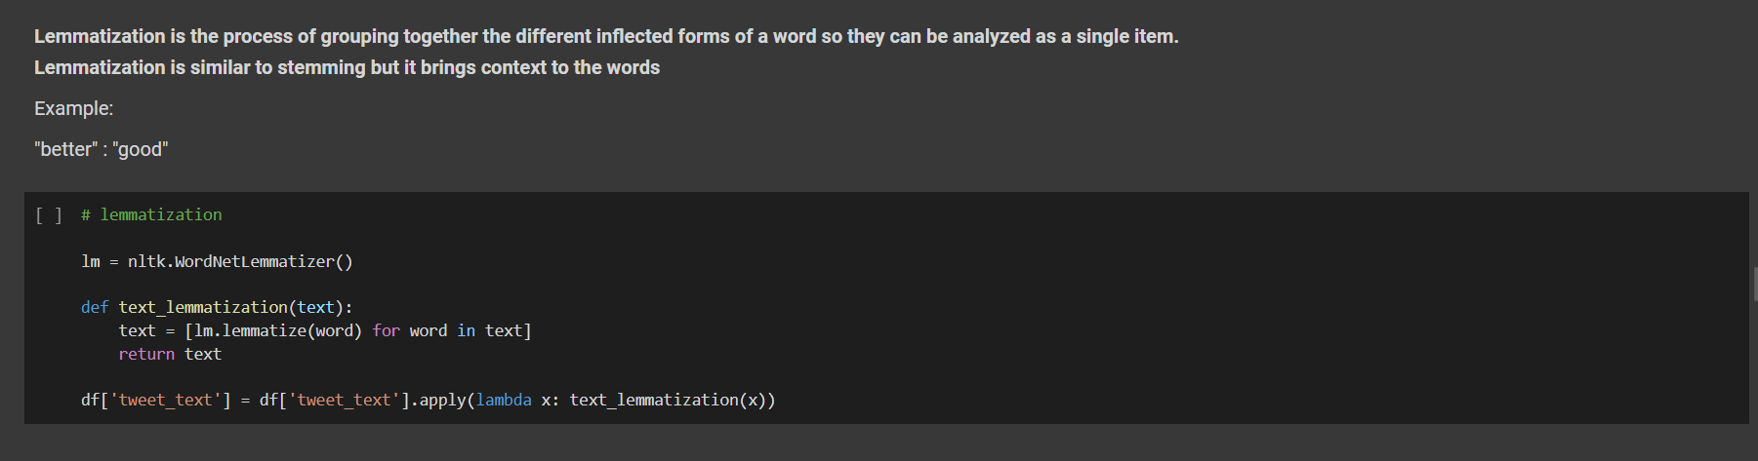

**5.DESCRIPTION OF UPDATED DATA IN THE DATASET**

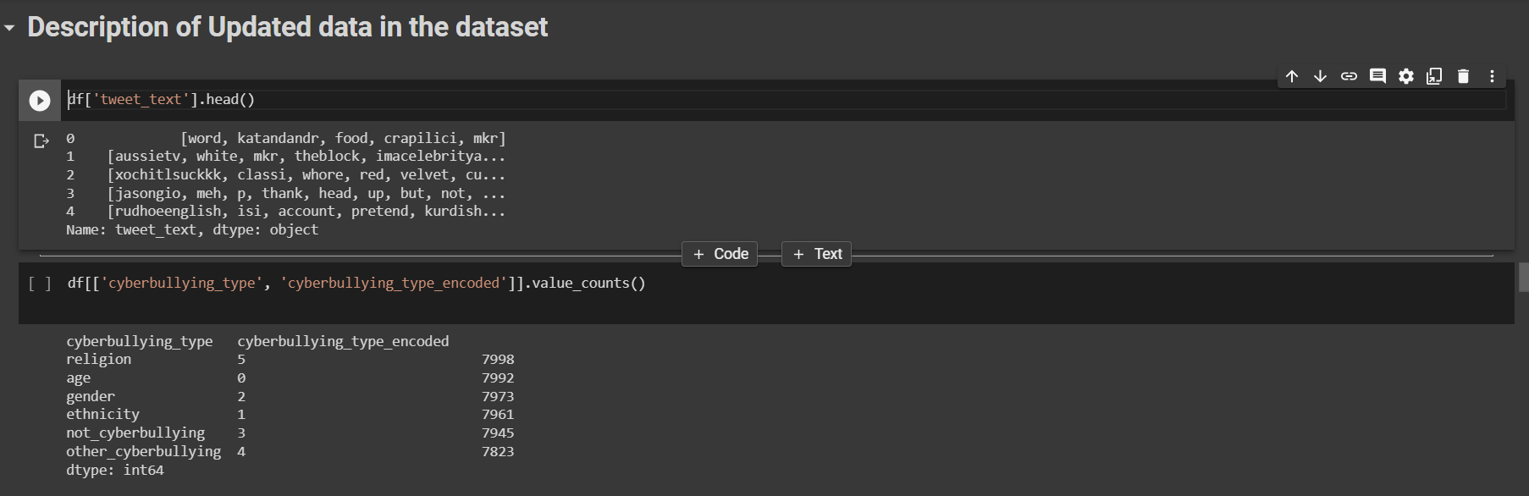

**6.WORD CLOUD PLOTTING**

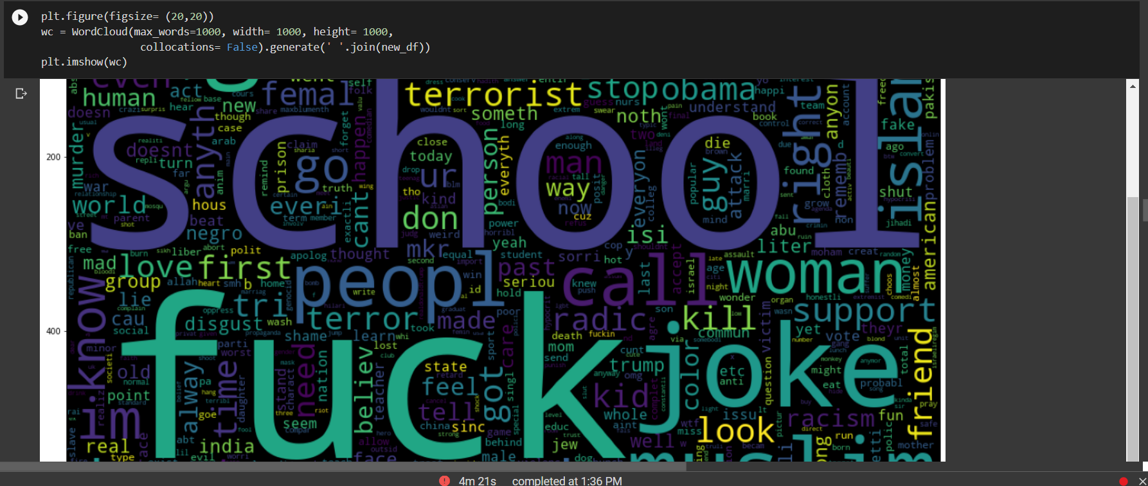

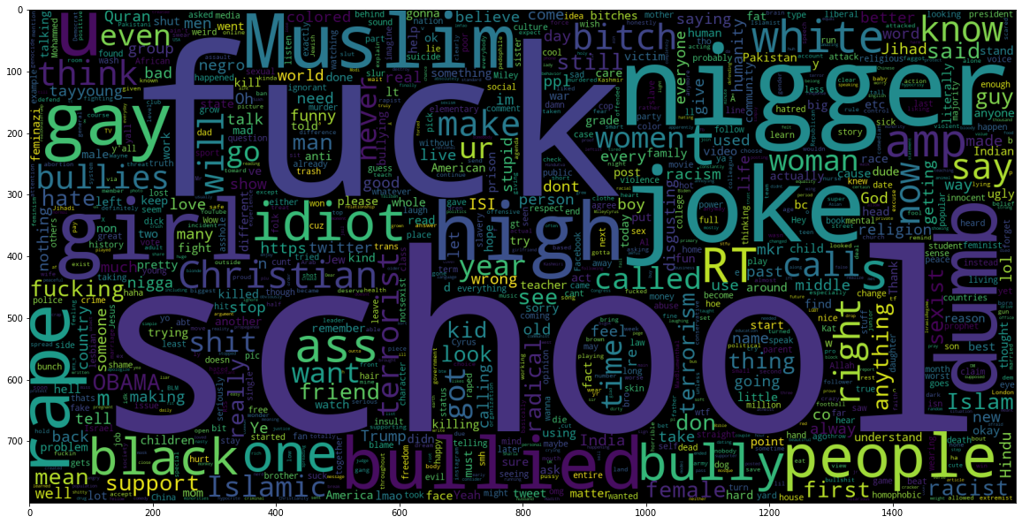

**7. INTITAL MODELLING**

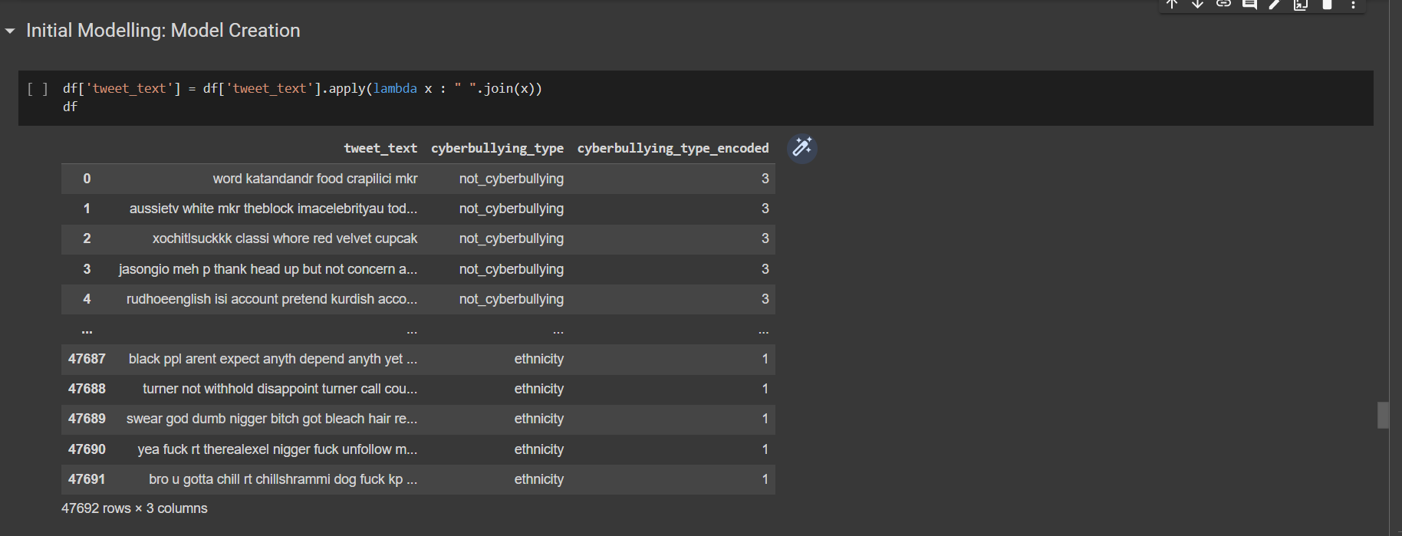

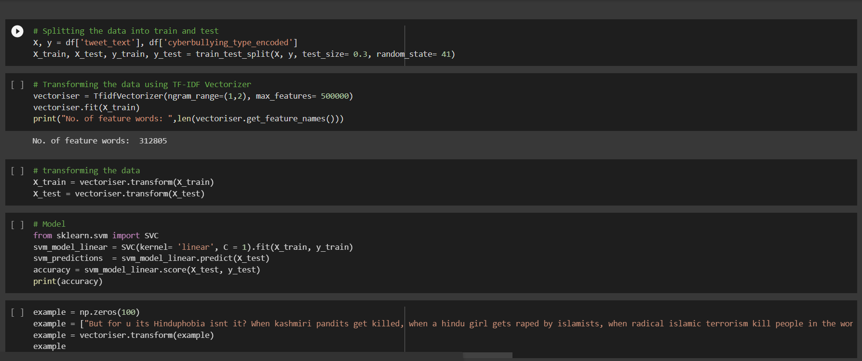

**8. CLASSIFIER MODEL**

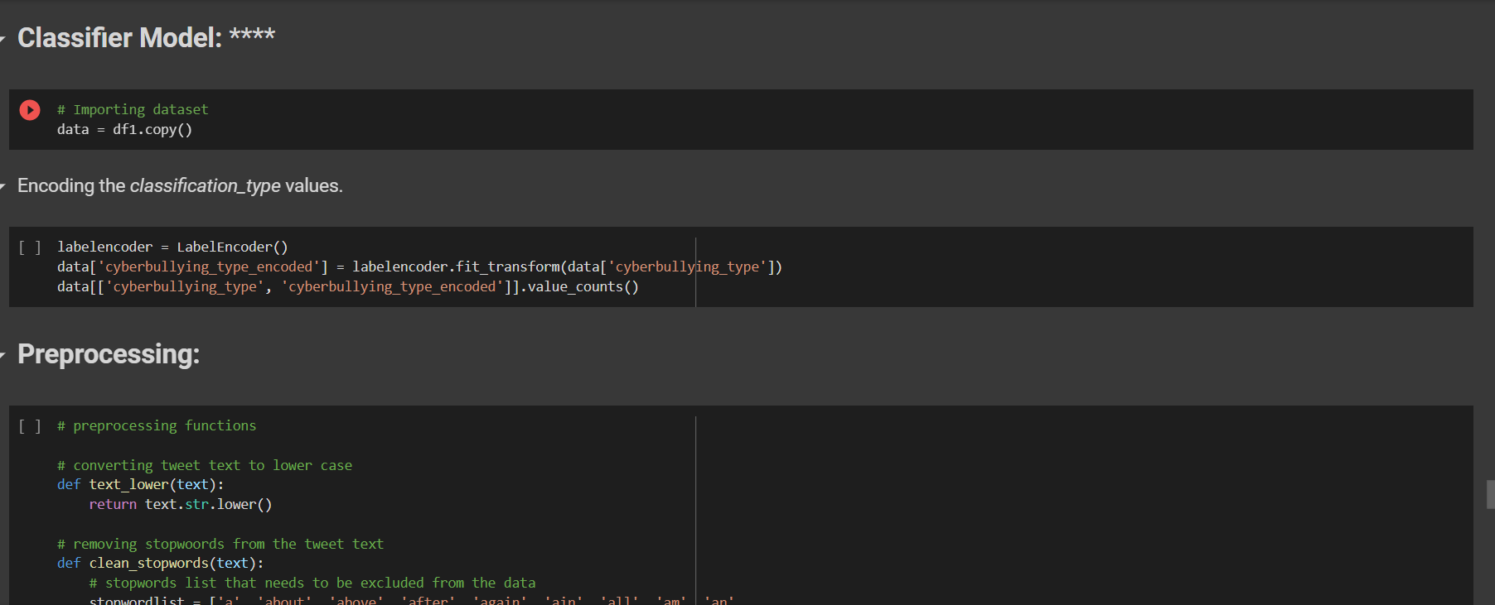

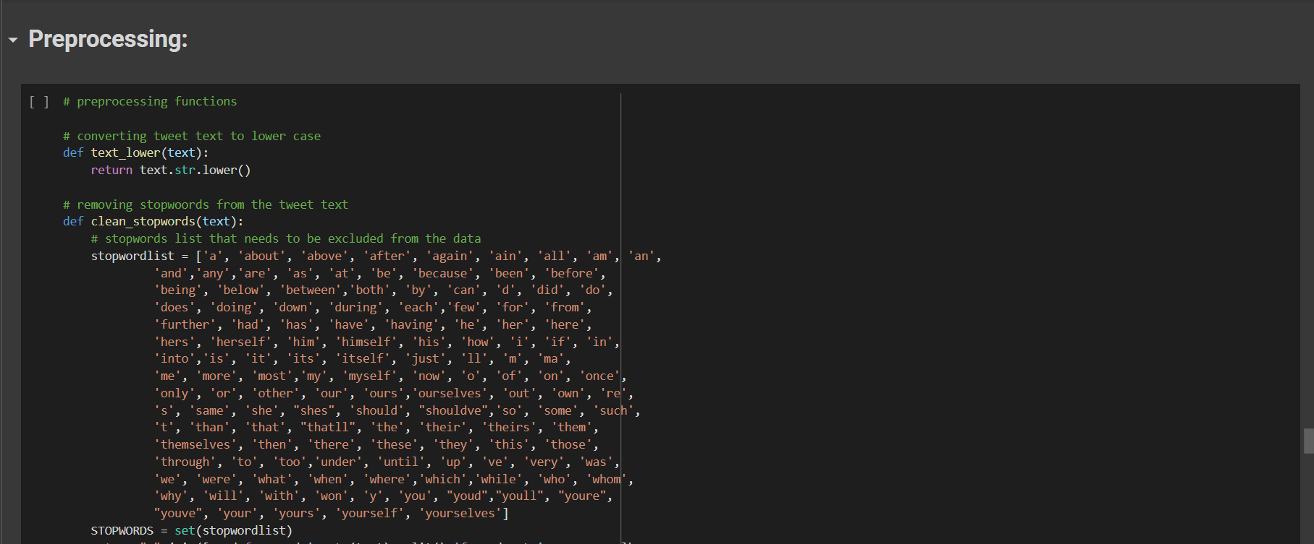

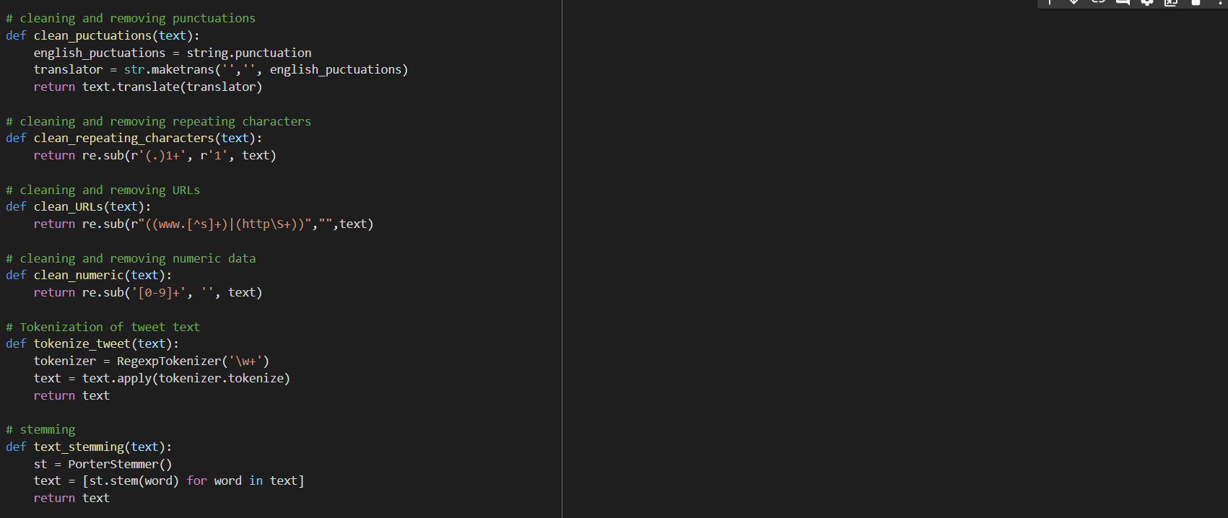

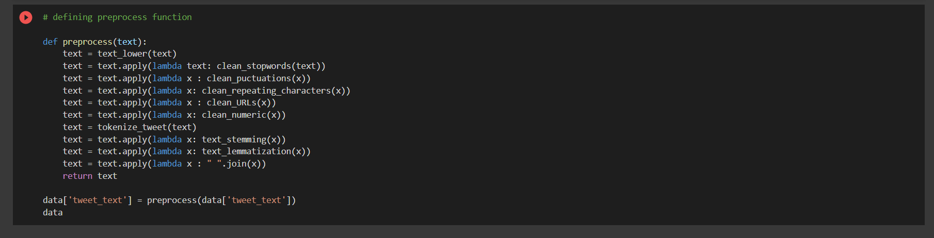

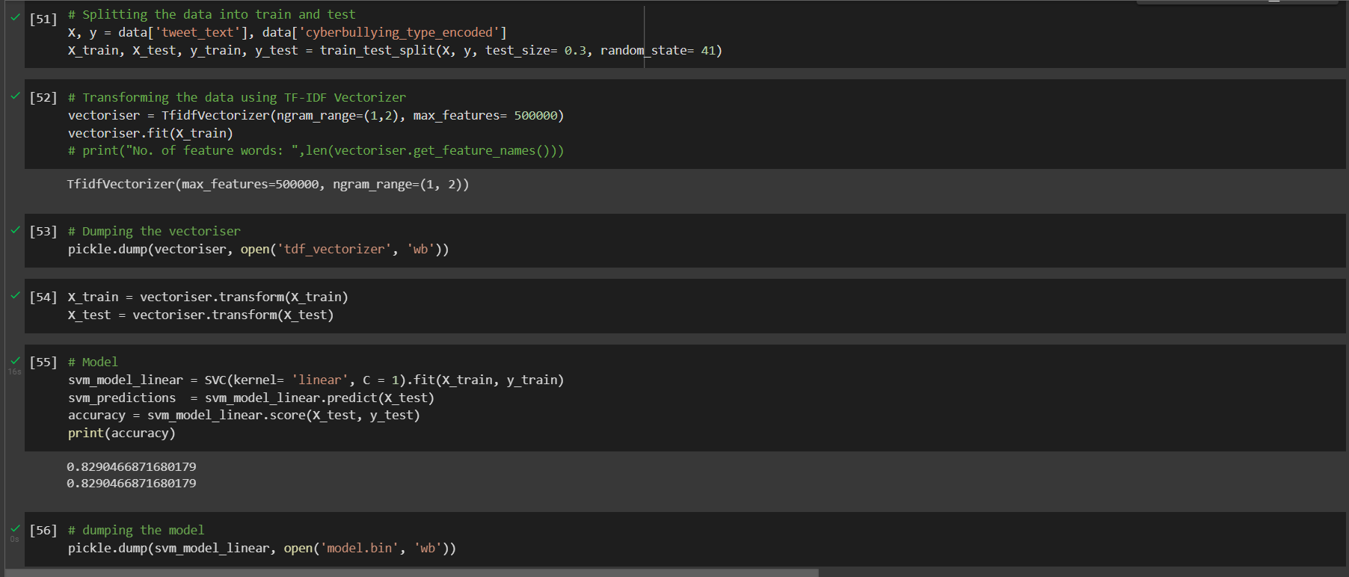

**9.PREDICTING CUSTOM INPUT**

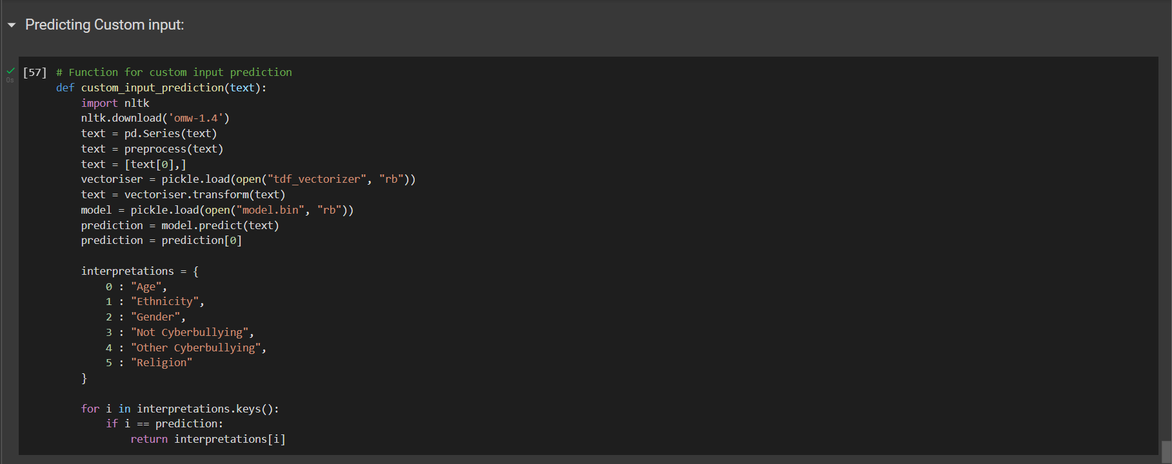

**10. OUTPUT**

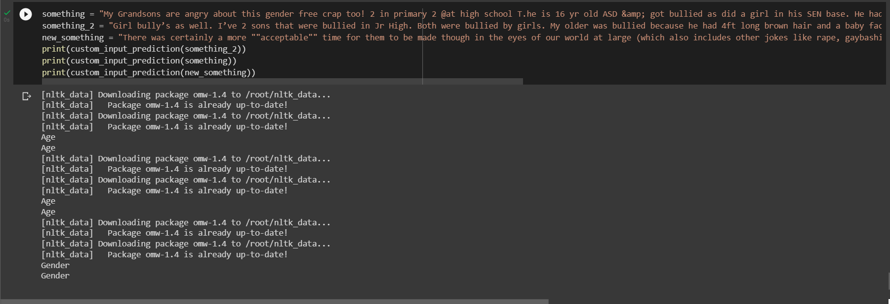

**CONCLUSION**

The goal of this project is to the predict and detect of cyberbullying-related posts on social media. Given the information overload on the web, manual monitoring for cyberbullying has become unfeasible.The detection of signals of cyberbullying would enhance moderation and allow to respond quickly when necessary. However, these posts could just as well indicate that cyberbullying is going on. The main aim of this project is that it presents a system to predict and detect signals of cyberbullying on social media, including different types of cyberbullying, covering posts from bullies, victims and bystanders.

**RESULT**

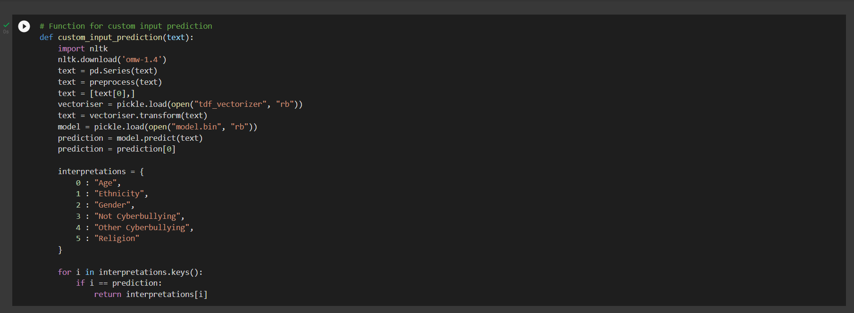

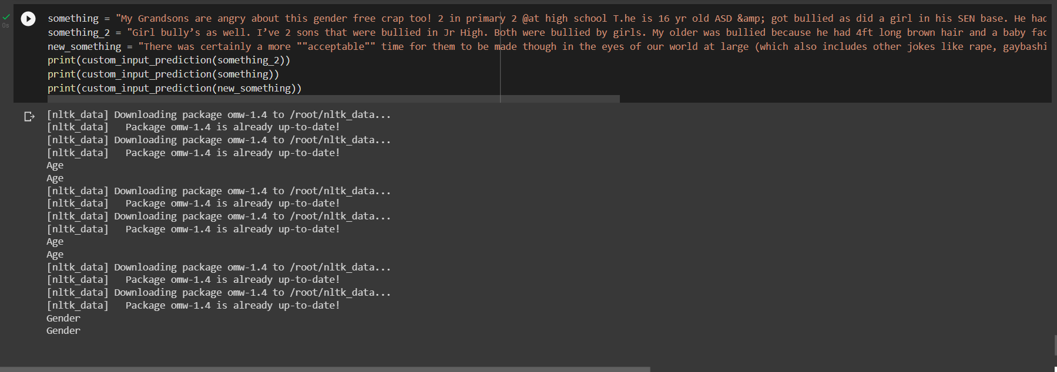

**BIBILOGRAPHY**

**References**

5372-Article Text-9814-1-10-20210513 (1).pdf

[Cyber Bullying Detection for Twitter Using ML Classification Algorithms (ijraset.com)](https://www.ijraset.com/research-paper/cyber-bullying-detection-for-twitter-using-ml)

[Cyberbullying severity detection: A machine learning approach | PLOS ONE](https://journals.plos.org/plosone/article?id=10.1371/journal.pone.0240924)

[GitHub - dhavalpotdar/detecting-offensive-language-in-tweets: Detecting cyberbullying in tweets using Machine Learning](https://github.com/dhavalpotdar/detecting-offensive-language-in-tweets)